**TASK 1:**

**1: (DATABASE CREATION)**

CREATE DATABASE TechShop;

USE TechShop;

**2: (SCHEMA CREATION)**

CREATE TABLE Customers (

CustomerID INT PRIMARY KEY AUTO_INCREMENT,

FirstName VARCHAR(50),

LastName VARCHAR(50),

Email VARCHAR(100),

Phone VARCHAR(15),

Address VARCHAR(255)

);

CREATE TABLE Products (

ProductID INT PRIMARY KEY AUTO_INCREMENT,

ProductName VARCHAR(100),

Description TEXT,

Price DECIMAL(10, 2)

);

CREATE TABLE Orders (

OrderID INT PRIMARY KEY AUTO_INCREMENT,

CustomerID INT,

OrderDate DATETIME,

TotalAmount DECIMAL(10, 2),

FOREIGN KEY (CustomerID) REFERENCES Customers(CustomerID)

);

CREATE TABLE OrderDetails (

OrderDetailID INT PRIMARY KEY AUTO_INCREMENT,

OrderID INT,

ProductID INT,

Quantity INT,

FOREIGN KEY (OrderID) REFERENCES Orders(OrderID),

FOREIGN KEY (ProductID) REFERENCES Products(ProductID)

);

CREATE TABLE Inventory (

InventoryID INT PRIMARY KEY AUTO_INCREMENT,

ProductID INT,

QuantityInStock INT,

LastStockUpdate DATETIME,

FOREIGN KEY (ProductID) REFERENCES Products(ProductID)

);

**3: (ER DIAGRAM)**

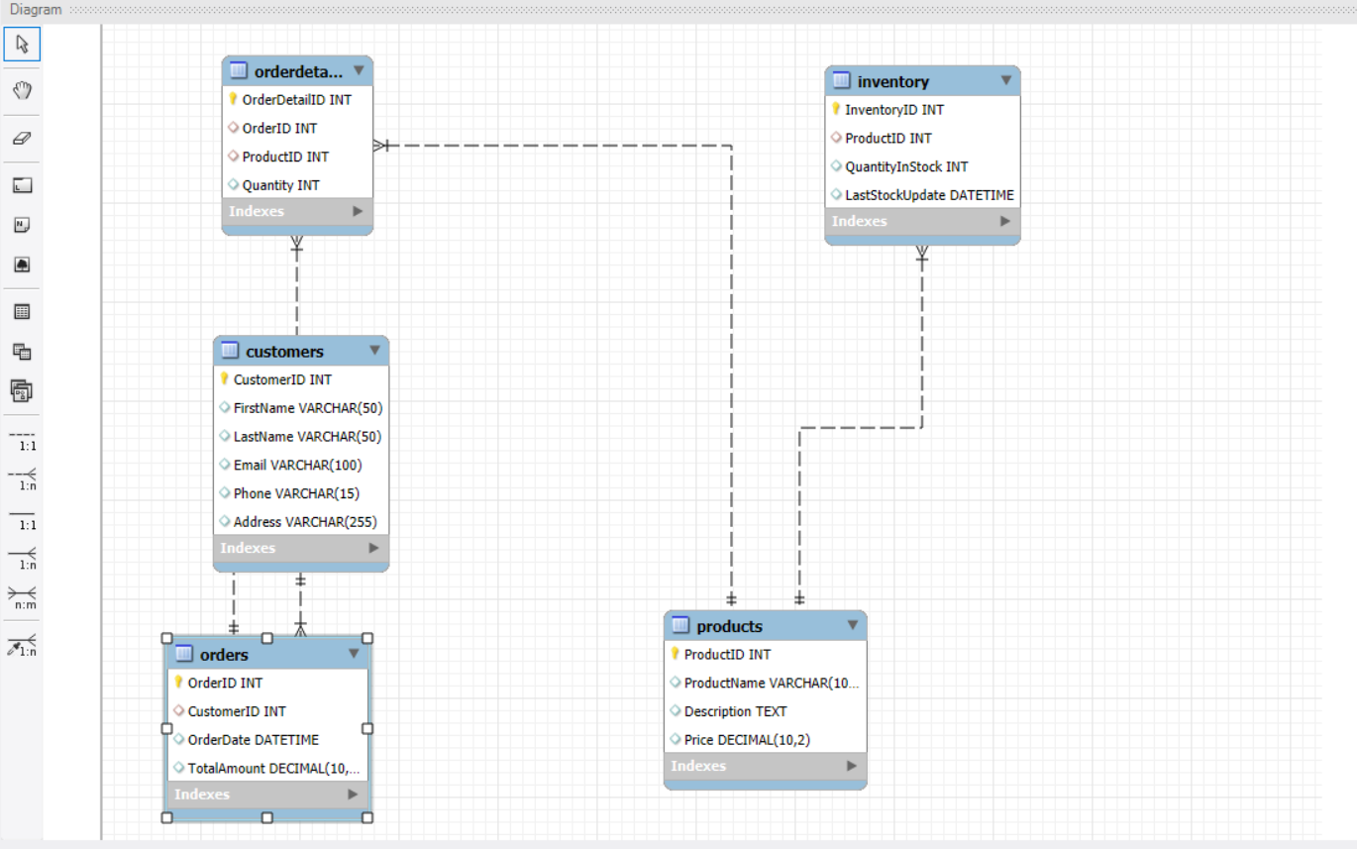

**5 (INSERTION OF DATA)**

INSERT INTO Customers (FirstName, LastName, Email, Phone, Address) VALUES

('Aarav', 'Singh', 'aarav.singh@example.com', '9876543210', '123, MG Road, Delhi'),

('Vihaan', 'Kumar', 'vihaan.kumar@example.com', '9123456789', '456, Church Street, Bangalore'),

('Reyansh', 'Verma', 'reyansh.verma@example.com', '9988776655', '789, Marine Drive, Mumbai'),

('Ishaan', 'Sharma', 'ishaan.sharma@example.com', '9988776644', '321, Connaught Place, Delhi'),

('Ayaan', 'Nair', 'ayaan.nair@example.com', '9191919191', '654, Brigade Road, Bangalore'),

('Arjun', 'Reddy', 'arjun.reddy@example.com', '8989898989', '234, Juhu, Mumbai'),

('Kabir', 'Patel', 'kabir.patel@example.com', '8787878787', '987, Banjara Hills, Hyderabad'),

('Siddharth', 'Kapoor', 'siddharth.kapoor@example.com', '7777777777', '12, Koramangala, Bangalore'),

('Krishna', 'Chawla', 'krishna.chawla@example.com', '6666666666', '543, Andheri, Mumbai'),

('Dev', 'Malhotra', 'dev.malhotra@example.com', '5555555555', '321, Connaught Place, Delhi');

INSERT INTO Products (ProductName, Description, Price) VALUES

('Smartphone', 'Latest model smartphone with advanced features.', 30000.00),

('Laptop', 'High-performance laptop for gaming and work.', 80000.00),

('Tablet', 'Lightweight tablet with a long battery life.', 25000.00),

('Smartwatch', 'Wearable smartwatch with health tracking.', 10000.00),

('Bluetooth Headphones', 'Noise-cancelling over-ear headphones.', 7000.00),

('Portable Charger', 'High-capacity power bank for charging on the go.', 3000.00),

('LED TV', '55-inch Ultra HD LED TV.', 50000.00),

('Gaming Console', 'Latest gaming console with exclusive games.', 40000.00),

('Wireless Mouse', 'Ergonomic wireless mouse for comfortable use.', 1500.00),

('External Hard Drive', '1TB external hard drive for extra storage.', 4000.00);

INSERT INTO Orders (CustomerID, OrderDate, TotalAmount) VALUES

(1, '2023-09-01', 37000.00),

(2, '2023-09-02', 80000.00),

(3, '2023-09-03', 25000.00),

(4, '2023-09-04', 21000.00),

(5, '2023-09-05', 50000.00),

(6, '2023-09-06', 40000.00),

(7, '2023-09-07', 4000.00),

(8, '2023-09-08', 16500.00),

(9, '2023-09-09', 10000.00),

(10, '2023-09-10', 5000.00);

INSERT INTO OrderDetails (OrderID, ProductID, Quantity) VALUES

(1, 1, 1),

(1, 5, 1),

(2, 2, 1),

(3, 3, 1),

(4, 4, 1),

(4, 6, 1),

(5, 7, 1),

(6, 8, 1),

(7, 9, 1),

(8, 10, 1),

(8, 6, 1),

(9, 4, 1),

(10, 5, 1);

mysql> INSERT INTO Inventory (ProductID, QuantityInStock, LastStockUpdate) VALUES

(1, 100, '2023-08-31 10:00:00'),

(2, 50, '2023-08-31 10:00:00'),

(3, 75, '2023-08-31 10:00:00'),

(4, 120, '2023-08-31 10:00:00'),

(5, 200, '2023-08-31 10:00:00'),

(6, 150, '2023-08-31 10:00:00'),

(7, 30, '2023-08-31 10:00:00'),

(8, 40, '2023-08-31 10:00:00'),

(9, 180, '2023-08-31 10:00:00'),

(10, 100, '2023-08-31 10:00:00');